|  |  |
| --- | --- |
| NAME | Muhammad Arslan Raza |
| ROLL# | 2020-EE-403 |

**Lab 9: Problem Set 3**

**Objective:** The objective of this problem set is how to write different programs on compiler

**Task 1:**

Use a list to solve the following problem: Read in 20 numbers. As each number is read, print it only if it is not a duplicate of a number already read.

**Code:**

L=[ ]

for i in range(20):

x=int(input("Enter the Number"))

if x not in L:

L=L+[x]

print(x)

print(L)

**Output:** 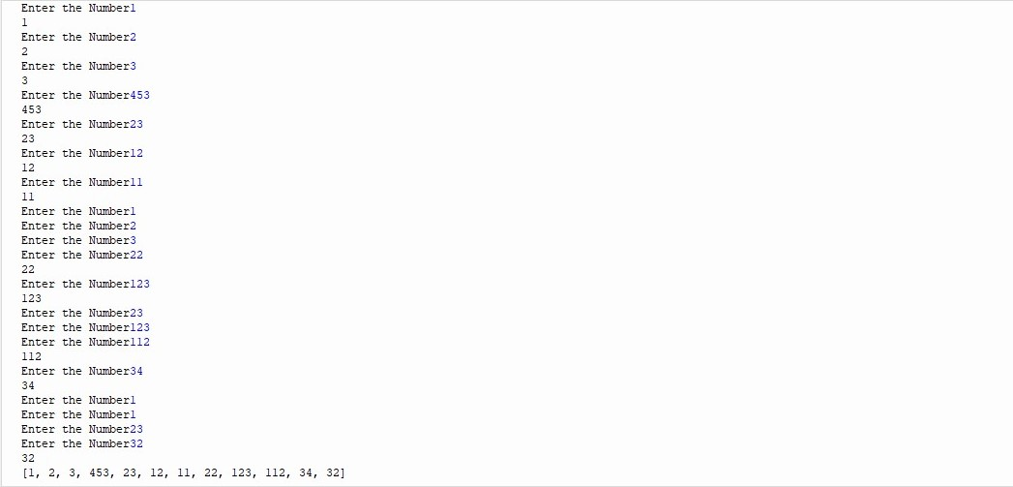

**Task 3:**

A prime integer is any integer greater than 1 that is evenly divisible only by itself and 1. The Sieve of Eratosthenes is a method of finding prime numbers. It operates as follows:

a) Create a list with all elements initialized to 1 (true). List elements with prime subscripts will remain 1. All other list elements will eventually be set to zero.  
b) Starting with list element 2, every time a list element is found whose value is 1, loop through the remainder of the list and set to zero every element whose subscript is a multiple of the subscript for the element with value 1. For list subscript 2, all elements beyond 2 in the list that are multiples of 2 will be set to zero (subscripts 4, 6, 8, 10, etc.); for list subscript 3, all elements beyond 3 in the list that are multiples of 3 will be set to zero (subscripts 6, 9, 12, 15, etc.); and so on.  
When this process is complete, the list elements that are still set to 1 indicate that the subscript is a prime number. These subscripts can then be printed. Write a program that uses a list of 1000 elements to determine and print the prime numbers between 2 and 999. Ignore element 0 of the list

**Code:**

list=[]

for n in range (1000):

list.append(1)

for j in range (2,1000):

if list[j]==1:

for m in range (j+1,1000):

if m%j==0:

list[m]=0

for k in range (1,1000):

if list[k]==1:

print(k,end =" ")

**Output:**

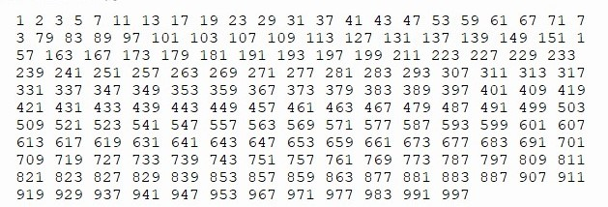

**Conclusion:**

Today In this lab I learn how to use a list to solve the different problems in python.